Site Plan
Site Purpose:
The Temple Inn & Suites is a hotel chain headquartered in Bethesda, MD that builds and manages specialized hotel accommodations near temple locations of The Church of Jesus Christ of Latter-day Saints around the world. The owner-operated company caters to temple workers, patrons, and their families by providing specialized services and accommodations that meet the needs of those patrons. The hotel accommodations and services are available to anyone willing to abide by the terms and policies outlined by the company. The overall goal of the website project is to promote and provide information about the specialized services that this hotel chain offers to meet the needs of temple patrons who come to serve in the temple or who participate in events such as sealings, weddings, receptions, and youth trips. The website should reflect the Church culture and be designed to support a temple-oriented theme as well as the concept of being a haven of comfort and accessibility.
Target Audience:
The site will target people who are members of The Church of Jesus Christ of Latter-day Saints looking for accommodation near the temple they wish to visit.
Site Map:
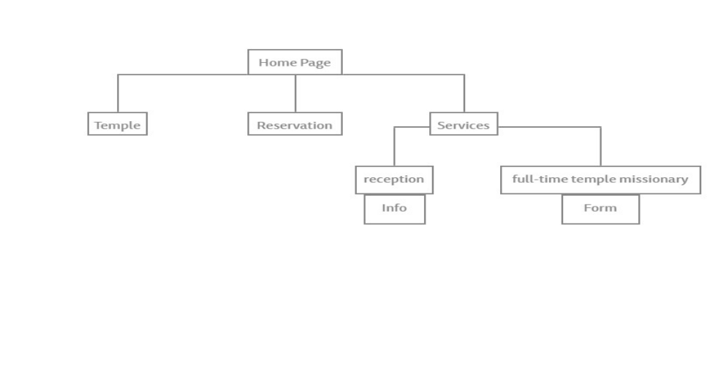
Color Scheme:
Below you can see the different colors that will be used on the website.
Palette URL: https://coolors.co/0a5198-ffffff-73cbf1-8b9ba0
Primary | Secondary | Accent 1 | Accent 2
#0A5198 | #FFFFFF | #73CBF1 | #8B9BA0

Typography:

Header Font:
Open Sans will be used as it has a professional look which is important for this type of website.

Paragraph Font
Lato will be used as it is an easily readable while keeping things professional.
Example of a normal Paragraph:
The Temple Inn & Suites is a hotel chain headquartered in Bethesda, MD that builds and manages specialized hotel accommodations near temple locations of The Church of Jesus Christ of Latter-day Saints around the world.

Example of a colored Paragraph:
The Temple Inn & Suites is a hotel chain headquartered in Bethesda, MD that builds and manages specialized hotel accommodations near temple locations of The Church if Jesus Christ of Latter-day Saints around the world.
Wireframes:
